Untersuchungsspektrum des Steroidlabors Heidelberg
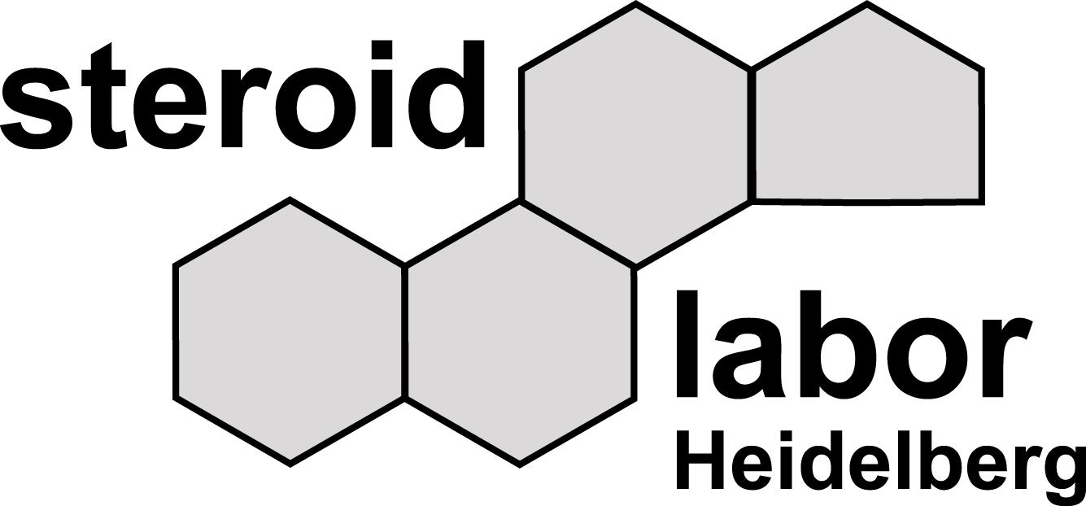

Untersuchungen  im Serum | Untersuchungen  im Urin | Untersuchungen  im Speichel | Untersuchungen  aus ETDA Plasma  ( gefroren )
Testosteron | Cortisol, frei (Freies F) | Cortisol | ACTH *
Aldosteron*  Androstendion | Cortison, frei (Freies E)  Gesamtaldosteron | 17α-Hydroxyprogesteron | Plasma-Renin-Aktivität **
Corticosteron (B)

Cortisol (F) *

Cortison (E)

Dehydroepiandrosteron (DHEA)

Dehydroepiandrosteron-Sulfat **
(DHEAS)

11-Desoxycorticosteron (DOC)

11-Desoxycortisol (Substanz S)

21-Desoxycortisol (21-DF)

Dihydrotestosteron

17α-Hydroxypregnenolon

17-Hydroxyprogesteron (17-OHP)

Messverfahren LCMS/MS *Clia **Elisa

